«College logo»

Tribhuvan University

Institute of Science and Technology

Final Project Report

On

Automated College Timetable Generator

Using a Genetic Algorithm
Submitted to
Department of Computer Application
Academia International College
Gwarko, Lalitpur
In partial fulfilment of the requirements for the
Bachelor of Science in Computer Science and Information Technology
(CACS452 — Project III, Seventh Semester)
Submitted by
Prajwal Basnet («symbol number»)
Shekhar Paudel («symbol number»)
«Month, Year»
Under the Supervision of
«Supervisor Name»
«College logo»

Tribhuvan University

Institute of Science and Technology

Academia International College

SUPERVISOR'S RECOMMENDATION
I hereby recommend that this project prepared under my supervision by Prajwal Basnet and Shekhar Paudel entitled "Automated College Timetable Generator" in partial fulfilment of the requirements for the degree of Bachelor of Science in Computer Science and Information Technology be processed for evaluation.

…………………………………
SIGNATURE
«Supervisor Name»
Supervisor
Department of Computer Application
Academia International College, Gwarko, Lalitpur
«College logo»

Tribhuvan University

Institute of Science and Technology

Academia International College

LETTER OF APPROVAL
This is to certify that this project prepared by Prajwal Basnet and Shekhar Paudel entitled "Automated College Timetable Generator" in partial fulfilment of the requirements for the degree of Bachelor of Science in Computer Science and Information Technology has been evaluated. In our opinion it is satisfactory in scope and quality as a project for the required degree.

SIGNATURE of Supervisor  …………………………  «Supervisor Name»  Academia International College  Gwarko, Lalitpur | SIGNATURE of Coordinator  …………………………  «Coordinator Name»  Co-ordinator  Academia International College  Gwarko, Lalitpur
SIGNATURE of Internal Examiner  …………………………  Internal Examiner | SIGNATURE of External Examiner  …………………………  External Examiner

ACKNOWLEDGEMENT
We extend our heartfelt gratitude to «Supervisor Name», our supervisor at Academia International College, for the guidance, patience and technical scrutiny that shaped this project. The insistence that every performance claim be measured rather than asserted is the reason Chapter 5 reports seeded, reproducible measurements instead of an estimate.
We are grateful to the Department of Computer Application and to the college management for the resources and platform to carry out this project, and to the faculty for the coursework in Design and Analysis of Algorithms and Web Technologies on which it builds. We also thank the administrative staff who described the existing manual timetabling process to us; the five shortcomings in Section 1.2 are their account of the problem. Finally, we thank our classmates for their feedback during the increment reviews.

Yours sincerely,
Prajwal Basnet («symbol number»)
Shekhar Paudel («symbol number»)

ABSTRACT
This project presents an Automated College Timetable Generator that constructs conflict-free weekly class schedules using a Genetic Algorithm implemented from scratch, with no optimisation or solver library. Timetabling is an NP-hard constraint satisfaction problem, and colleges affiliated with Tribhuvan University typically build the schedule by hand over two to three weeks, often with double-bookings that surface only after the semester begins.
The system schedules a small sample dataset — two programmes with two sections each, eight courses, five teachers, three rooms and four batches, giving 48 weekly sessions in 36 time slots. Each candidate timetable is a chromosome with one gene per session, scored by f = 1 / (1 + total penalty). Teacher, room and batch clashes cost 100 each; qualification and room capacity are guaranteed by construction; two small soft penalties discourage idle gaps and uneven daily loads. Tournament selection, single-point crossover, per-gene mutation and elitism drive the search, followed by a small targeted repair step. The system is a browser-only React and TypeScript application that draws the convergence live and shows the result by batch, teacher or room. The database, login and export of the proposal were left out.
Over ten seeded runs the system finds a clash-free timetable in a mean of 2.2 generations and 26 milliseconds, and every run reaches fitness 1.0, against a requirement of 500 generations and 120 seconds. Without repair the plain algorithm needs 16.2 generations and only two of ten runs reach fitness 1.0. On an earlier 180-session dataset of the proposal's NFR1 size, the system was clash-free in 384 ms mean.
Keywords: Genetic Algorithm, Timetable Scheduling, NP-hard, Constraint Satisfaction, Memetic Algorithm, TypeScript.

LIST OF FIGURES
Figure | Title | Page
Figure 1.1 | Incremental Model of Development | «p»
Figure 3.1 | Use Case Diagram of the User | «p»
Figure 3.2 | Gantt Chart of the Project Schedule | «p»
Figure 3.3 | Class Diagram of the Algorithm | «p»
Figure 3.4 | Sequence Diagram of Timetable Generation | «p»
Figure 3.5 | Activity Diagram of the Genetic Algorithm | «p»
Figure 4.1 | System Architecture and Components | «p»
Figure 4.2 | Chromosome Encoding of a Candidate Timetable | «p»
Figure 5.1 | The Application After a Run | «p»
Figure 5.2 | Convergence of Hard Violations and Best Fitness | «p»

UML figures are drawn from the Mermaid source in UML.md and exported to PNG for the printed report. Figures 5.1 and 5.2 are screenshots of the running application.

LIST OF TABLES
Table | Title | Page
Table 1.1 | Deviations from the Proposal | «p»
Table 3.1 | Functional Requirements | «p»
Table 3.2 | Non-Functional Requirements | «p»
Table 3.3 | Hard Constraints and Penalty Weights | «p»
Table 3.4 | Soft Constraints and Penalty Weights | «p»
Table 3.5 | Technology Package Table | «p»
Table 3.6 | Economic Feasibility Table | «p»
Table 4.1 | Sample Dataset | «p»
Table 4.2 | Modules of the Genetic Algorithm Engine | «p»
Table 4.3 | Genetic Algorithm Parameters | «p»
Table 5.1 | Test Environment Table | «p»
Table 5.2 | Test Cases | «p»
Table 5.3 | Ten Seeded Runs With and Without Repair | «p»
Table 5.4 | Summary: Effect of the Repair Step | «p»

LIST OF ABBREVIATIONS
CSIT | Computer Science and Information Technology
FR | Functional Requirement
GA | Genetic Algorithm
NFR | Non-Functional Requirement
NP | Nondeterministic Polynomial time
PDF | Portable Document Format
UML | Unified Modeling Language

Chapter 1: Introduction

1.1 Introduction
The Automated College Timetable Generator constructs a conflict-free weekly class schedule for a college. Constraints on teachers, batches, rooms and time slots interact, so fixing one clash often creates another. Timetabling is NP-hard [1], and even the small sample dataset here admits on the order of 10^95 candidate timetables, so exhaustive search is impossible.
This project applies a Genetic Algorithm [2]–[4], written from scratch in TypeScript, in a browser page where the user presses Generate timetable and watches the search live.

1.2 Problem Statement
Colleges affiliated with Tribhuvan University often spend two to three weeks building timetables by hand, with five shortcomings:
Shortcoming | Consequence
Resource conflicts | Double-booked teachers or rooms are hard to spot by eye.
Time inefficiency | Weeks each semester; any change forces near-complete rework.
Suboptimal utilisation | Large rooms for small classes; long teacher idle gaps.
Lack of scalability | Each new batch interacts with every existing one.
No standardised validation | Errors surface only after the semester has begun.

The problem is to build a conflict-free timetable automatically, in seconds rather than weeks.

1.3 Objectives
- To design and implement a custom Genetic Algorithm from scratch that produces a weekly timetable satisfying all hard constraints.
- To incorporate soft-constraint optimisation in the fitness function, reducing instructor idle gaps and evening out each batch's daily load.
- To display the timetable, and the algorithm's progress while it runs, from the batch, instructor and room perspectives.
- To evaluate convergence and the effect of the repair step over seeded runs.

1.4 Scope and Limitation

1.4.1 Scope
The scope is a from-scratch GA (seven steps plus repair), a small editable dataset (Table 4.1) with data checks, a live chart, a timetable grid and ten tests.

1.4.2 Limitation
No data is saved, there is no login or export, and the model is simplified (Section 6.2).

1.4.3 Deviations from the Proposal
An earlier full-stack build was removed to show only the algorithm (Table 1.1).
Table 1.1: Deviations from the Proposal
Proposal item | Status in the delivered system
FR1 data management; FR3 grid filters | Partial: unsaved in-browser editing; grid by batch, teacher or room
FR5 export; FR6 login; NFR3 database | Not implemented
NFR4 — errors for impossible data | Partial: four checks (§5.1.2)
Step 3 — capacity as a penalty | Changed: guaranteed by construction, as is qualification
Constraints; Steps 1–7 | Extended: batch clash (§4.3.3); repair (§4.3.6)

1.5 Development Methodology

1.5.1 Incremental Model
The Incremental Model was followed, each increment ending in testing and review: (1) data and encoding; (2) Steps 2–7 as specified, which converged slowly; (3) repair and soft weights below one clash; (4) interface, tests and measurements, removing the server, database and login.
«Figure 1.1 — Incremental Model of Development»
Figure 1.1: Incremental Model

1.6 Report Organization
Chapters 2–6 cover literature, analysis, design, implementation and testing, and conclusion.

Chapter 2: Background Study and Literature Review

2.1 Background Study
Candidate schedules grow exponentially with the sessions, and Even and Itai proved timetabling NP-hard [1]. Manual methods persist in Nepali colleges because commercial software is costly.
Terminologies related to this project:
- Session: one weekly lecture of a course for one batch. Time slot: one (day, period) pair; six days × six periods give 36. Batch: a cohort of one programme and section.
- Hard / soft constraint: a condition a usable timetable must meet / a property that only improves quality.
- Chromosome / gene: one candidate timetable / the teacher, room and slot of one session. Fitness: its score, 1.0 when flawless. Generation: one cycle of evaluation, selection, crossover and mutation. Elitism: carrying the best forward unchanged.
The Genetic Algorithm scores a population of candidates, selects fitter ones as parents, and recombines and mutates them into the next generation [2]. It needs no gradients, so it suits a discrete, constrained problem such as timetabling [3].

2.2 Literature Review
Academic literature. Colorni, Dorigo and Maniezzo found genetic algorithms effective on highly constrained school timetabling, especially with local search [4], as Section 5.3.3 confirms. Abramson used simulated annealing, showing metaheuristics viable where exact methods are not, but sensitive to parameters [5].
Existing systems. FET is an open-source heuristic scheduler with a large constraint vocabulary, but a desktop application with a dense interface. aSc TimeTables is a mature commercial product, but costly for a Nepali college and school-oriented. UniTime is a capable open-source university system whose deployment burden presumes a much larger institution.
The gap addressed. These tools are heavy or costly and hide the algorithm; this project writes a small engine from scratch, shows its convergence live, and measures it.

Chapter 3: System Analysis

3.1 System Analysis

3.1.1 Requirement Analysis

3.1.1.1 Functional Requirements
Table 3.1 gives each requirement's status; Figure 3.1 shows the User's five use cases: Edit college data, Set GA parameters, Generate timetable, Watch progress, View timetable.
Table 3.1: Functional Requirements
ID | Requirement | Status
FR1 | CRUD on all college data, including departments and time slots | Partial — four entities, unsaved
FR2 | GA engine: no teacher or room double-booking, no capacity violation | Implemented — plus batch clash
FR3 | Grid by teacher, batch, room, department; lab colouring | Partial — batch, teacher, room
FR4 | Real-time generation number and fitness | Implemented — tiles and live chart
FR5 | Export to PDF and Excel | Not implemented
FR6 | Authentication with role-based access control | Not implemented

«Figure 3.1 — Use Case Diagram of the User»
Figure 3.1: Use Case Diagram of the User

3.1.1.2 Non-Functional Requirements
Table 3.2: Non-Functional Requirements
ID | Requirement | Status
NFR1 | Clash-free for 6 programmes, 30 courses, 20 teachers, 15 rooms in 120 s | Met on the earlier 180-session data
NFR2 | Responsive interface from 768 px to desktop | Met — fluid layout
NFR3 | Persistence in a relational database | Not implemented
NFR4 | Meaningful errors for impossible data | Partial — four checks (§5.1.2)

3.1.1.3 Constraint Specification
Table 3.3: Hard Constraints and Penalty Weights
Constraint | How it is enforced
Teacher assigned to two sessions in one slot | Penalty 100 each
Room assigned to two sessions in one slot | Penalty 100 each
Batch assigned to two sessions in one slot | Penalty 100 each
Room smaller than the batch | By construction (only large rooms offered)
Teacher not qualified for the course | By construction (only qualified teachers)

Table 3.4: Soft Constraints and Penalty Weights
Constraint | Penalty weight
Teacher idle gap between taught periods on one day | 0.3 each
Uneven spread of a batch's classes across the week | 0.2 × deviation from daily mean

3.1.2 Feasibility Analysis

3.1.2.1 Technical Feasibility
No server, database or solver library is needed, so nothing is opaque (Table 3.5).
Table 3.5: Technology Package Table
Package | Version | Compatibility | Purpose
React | 18.3 | ES2020 browsers | User interface
TypeScript | 5.7 | — | Language
Vite | 6.0 | Node.js ≥ 20 | Dev server and build
Recharts | 2.15 | React ≥ 17 | Live chart (FR4)
Vitest | 2.1 | Node.js ≥ 20 | Automated tests
GA engine | — | — | From scratch; no dependencies

3.1.2.2 Operational Feasibility
The system runs in any modern browser with no installation. All tools are open source (Table 3.6).

3.1.2.3 Economic Feasibility
Table 3.6: Economic Feasibility Table
Cost category | Item | Cost
Development | Own hardware; open-source software; no solver licence | Nil
Deployment and operation | Static hosting or local run; maintenance | Nil; minimal

3.1.2.4 Schedule Feasibility
The four increments of Section 1.5.1 each ended in a review.
«Figure 3.2 — Gantt Chart»
Figure 3.2: Gantt Chart of the Project Schedule

3.1.3 Analysis

3.1.3.1 Class Diagram
Figure 3.3 shows the data types and the algorithm types (Problem, Session, Gene, Chromosome, …).
«Figure 3.3 — Class Diagram of the Algorithm»
Figure 3.3: Class Diagram of the Algorithm

3.1.3.2 Sequence Diagram
The App calls buildProblem and runGA; each generation's Progress redraws the chart, and the Result goes to the Timetable component (Figure 3.4).
«Figure 3.4 — Sequence Diagram of Timetable Generation»
Figure 3.4: Sequence Diagram of Timetable Generation

3.1.3.3 Activity Diagram
Figure 3.5 shows the seven steps of the algorithm, with repair marked as an addition.
«Figure 3.5 — Activity Diagram of the Genetic Algorithm»
Figure 3.5: Activity Diagram of the Genetic Algorithm

Chapter 4: System Design

4.1 Architectural Design
The system runs entirely in the browser and has three parts: the data (src/data.ts), the algorithm (src/ga/, one file per step, pure TypeScript with no dependency on React, so the tests run the same code) and the interface (src/App.tsx, src/DataEditor.tsx, src/Timetable.tsx). Nothing in src/ga/ depends on the interface. The algorithm yields after each generation so the chart can redraw.
«Figure 4.1 — System Architecture and Components»
Figure 4.1: System Architecture and Components

4.2 Data Design
Table 4.1: Sample Dataset
Item | Count | Notes
Programmes | 2 | BCA, B.Sc. CSIT
Courses | 8 | Four per programme, each 3 lectures a week
Teachers | 5 | Each qualified for two or three courses; qualifications overlap
Rooms | 3 | A-101 (50), A-102 (45), B-101 (40)
Batches | 4 | BCA 5A (48), BCA 5B (44), CSIT 5A (40), CSIT 5B (38)
Sessions | 48 | 4 batches × 4 courses × 3 lectures
Time slots | 36 | Sunday–Friday × six periods, 06:30–12:30

NFR1 was measured on an earlier version of this file (6 programmes, 30 courses, 20 teachers, 15 rooms, 12 batches, 180 sessions), kept in git history at commit 4a72724.

4.3 Algorithm Details

4.3.1 Chromosome Encoding (Step 1)
A timetable is an array with one gene per session; the session list is fixed, so gene i stores only the teacher, room and time slot of session i. Each session also holds the lists of qualified teachers and of rooms large enough for its batch, and every operator draws only from these lists, so the algorithm only has to remove clashes.
«Figure 4.2 — Chromosome Encoding»
Figure 4.2: Chromosome Encoding of a Candidate Timetable

4.3.2 The Genetic Algorithm
Table 4.2: Modules of the Genetic Algorithm Engine
Module | Responsibility
problem.ts | Step 1 — encoding: sessions, genes, chromosomes
population.ts | Step 2 — random population initialisation
fitness.ts | Step 3 — fitness evaluation
selection.ts | Step 4 — tournament selection
crossover.ts | Step 5 — single-point crossover
mutation.ts | Step 6 — mutation
engine.ts | Step 7 — the evolutionary loop and termination
repair.ts | Targeted repair (our addition)
rng.ts | Seeded random number generator (mulberry32), so every run is reproducible

1 sessions ← BUILD-PROBLEM(data); population ← 100 random chromosomes // Steps 1, 2
2 for generation ← 1 to 1000
3 evaluate fitness of every individual // Step 3
4 if a stopping rule of Section 4.3.5 holds: return best // Step 7
5 next ← top 20% of population // elitism
6 while |next| < 100
7 c ← rand < 0.8 ? CROSSOVER(TOURNAMENT(5), TOURNAMENT(5)) // Steps 4, 5
8 : COPY(TOURNAMENT(5))
9 MUTATE(c, 0.05); REPAIR(c); add c to next // Step 6 + repair
10 population ← next
Fitness is f = 1 / (1 + total penalty): 100 per clash plus the soft penalties of Table 3.4, so a flawless timetable scores 1.0. In one pass, each (teacher, slot), (room, slot) and (batch, slot) cell remembers the first gene to take it; a later gene there is a clash, and both genes are recorded for repair. Selection is a tournament of k = 5, which uses only the ordering of fitness; this matters because one clash scores about 0.0099 and two about 0.0050, too narrow a band for roulette-wheel selection. Crossover is single-point at rate 0.8; because gene i always describes session i, the child is always complete. Mutation (rate 0.05 per gene) gives a gene a new room, a new slot, or both, from the session's lists.
Table 4.3: Genetic Algorithm Parameters
Parameter | Value | Source
Population size | 100 | Proposal
Maximum generations | 1000 | Proposal
Crossover rate | 0.8 | Proposal
Mutation rate (per gene) | 0.05 | Proposal
Tournament size (k) | 5 | Proposal
Elitism | Top 20% | Proposal
Hard constraint weight | 100 | Proposal
Patience (generations without improvement, once clash-free) | 20 | Our addition (§4.3.5)
Random seed | 42 | Our addition, for reproducibility

Time complexity. A fitness evaluation is O(G) for G genes and a generation O(N · G), with at most 96 repair evaluations per child; at N = 100, G = 48 it takes around ten milliseconds.

4.3.3 Constraint Addition — Batch Clash
Without it, one batch could sit in two rooms at once while meeting every constraint the proposal names, so the batch clash is a third hard constraint with penalty 100.

4.3.4 Soft Weights Below One Clash
All soft penalty together stays below one clash, so removing a clash is always worth more than any soft improvement: clashes are fixed first, and the timetable is polished afterwards.

4.3.5 Termination (Step 7)
The loop stops when (1) best fitness equals 1.0, the proposal's condition; (2) the best is clash-free and has not improved for 20 generations, a fallback for data where some soft penalty cannot be removed; or (3) 1000 generations have run.

4.3.6 Targeted Repair — Our Addition
Random mutation rarely hits the few genes that actually clash. After mutation, repair takes up to 12 clashing genes and tries 8 random placements for each, keeping a change only if the total penalty falls, so it never makes a timetable worse. A genetic algorithm combined with such local search is a memetic algorithm.

Chapter 5: Implementation and Testing

5.1 Implementation

5.1.1 Tools Used
The tools are those of Table 3.5: React, TypeScript, Vite, Recharts and Vitest. The genetic algorithm itself uses none of them.

5.1.2 Implementation of Modules
Data (src/data.ts) holds the sample data; qualifications overlap so most courses have two or three qualified teachers. Encoding (src/ga/problem.ts): buildProblem expands batches into sessions and reports a plain error, disabling Generate, for a duplicate course code, a teacher or batch listing an unknown course, a course with no qualified teacher, or a batch that fits no room. Algorithm (src/ga/): one file per step (Table 4.2); runGA returns the best chromosome, its fitness, the generation it became clash-free and the time. Data editor (src/DataEditor.tsx): four editable tabs; renaming a course code updates every list that uses it. Interface (src/App.tsx, src/Timetable.tsx): GA parameter fields pre-filled with the proposal's values, the Generate timetable button, four stat tiles, the live chart, and a six-day by six-period grid. Every field and tile, and each file in src/ga/, carries a one-line explanation.
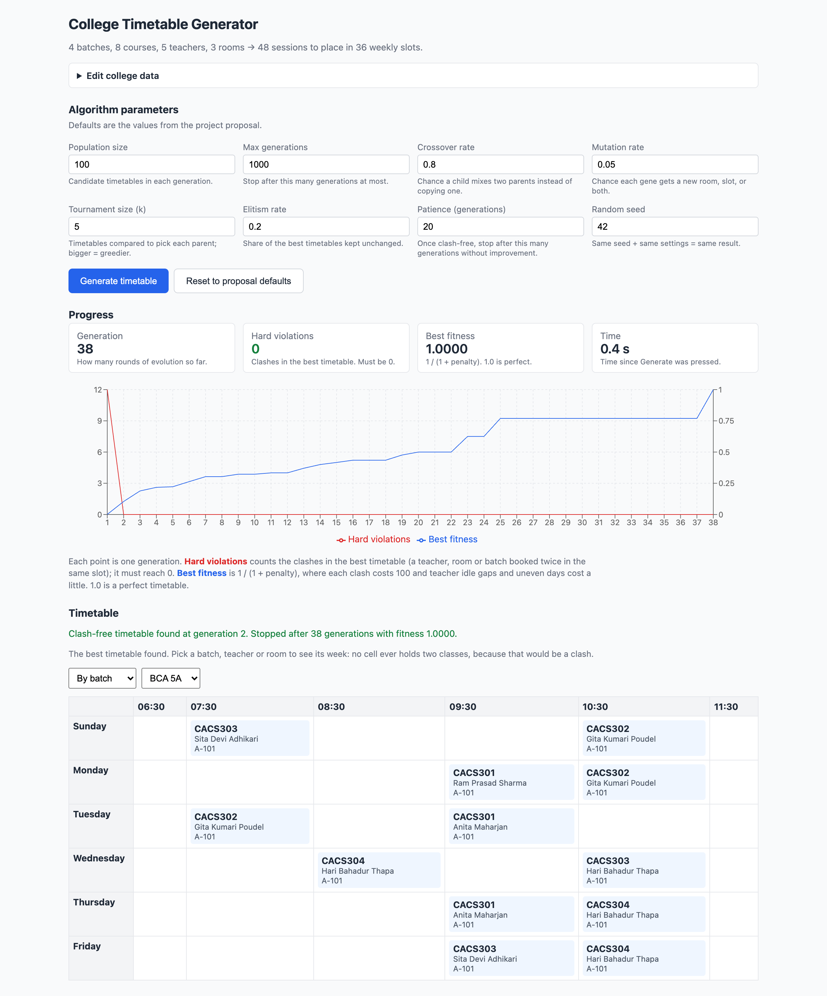
Figure 5.1: The Application After a Run

5.2 Testing
Ten tests in src/ga/ga.test.ts use the college data and a hand-built two-session problem.
Table 5.1: Test Environment Table
Operating System | macOS (darwin arm64)
Runtime | Node.js 20
Browser | Google Chrome, Brave, Firefox
Test Runner | Vitest 2

5.2.1 Test Cases for Unit Testing
Tests 1–9 (Table 5.2) check the encoding (FR2, NFR4), fitness function and operators (FR2).

5.2.2 Test Cases for System Testing
Test 10 runs the full algorithm (FR2, the 500-generation target). The interface was tested by hand: the chart and tiles update live and the drop-downs show the matching timetable.
Table 5.2: Test Cases
# | Area | Action | Expected Result | Result
1 | Encoding | Build from the college dataset | 48 sessions | Pass
2 | Encoding | Inspect teacher and room lists | All qualified; all rooms fit | Pass
3 | Encoding | Use an unknown course code | Error naming it | Pass
4 | Encoding | Give two courses one code | Error naming it | Pass
5 | Fitness | Two sessions, no shared resource | 0 violations; f = 1/(1 + penalty) | Pass
6 | Fitness | Two sessions, same teacher and slot | 1 violation; both genes flagged | Pass
7 | Fitness | Two sessions, same room and slot | 1 violation | Pass
8 | Operators | Cross two chromosomes | Each gene from a parent | Pass
9 | Operators | Mutate at rate 1.0 | Rooms from list; slots in 0–35 | Pass
10 | System | Full run, default seed | Clash-free within 500 gens, 120 s | Pass

5.3 Result Analysis
All results use the parameters of Table 4.3 and seeds 1–10 (and 42, the demo default) on the environment of Table 5.1, so they are reproducible.

5.3.1 Performance and NFR1 Compliance
Table 5.3: Ten Seeded Runs With and Without Repair
Seed | Clashes, gen. 1 | Repair: clash-free at | Repair: total gens | No repair: clash-free at | No repair: total gens | No repair: fitness
1 | 10 | 2 | 27 | 13 | 84 | 1.0000
2 | 12 | 2 | 23 | 13 | 113 | 0.7692
3 | 13 | 2 | 47 | 17 | 105 | 0.5000
4 | 12 | 2 | 32 | 19 | 103 | 0.4348
5 | 14 | 3 | 25 | 18 | 103 | 0.4348
6 | 12 | 2 | 22 | 22 | 85 | 0.5882
7 | 13 | 2 | 41 | 17 | 120 | 1.0000
8 | 14 | 2 | 30 | 13 | 133 | 0.7143
9 | 14 | 3 | 18 | 19 | 107 | 0.7692
10 | 10 | 2 | 42 | 11 | 84 | 0.4167

With repair every run reached fitness 1.0000 (zero soft penalty) after 18–47 generations (138–327 ms); the patience rule never fired.
Table 5.4: Summary: Effect of the Repair Step
Metric | With repair | Without repair | Budget
Runs reaching a clash-free timetable | 10 / 10 | 10 / 10 | —
Generations to clash-free (mean / worst) | 2.2 / 3 | 16.2 / 22 | 500
Time to clash-free (mean / worst) | 26 ms / 38 ms | — | 120,000 ms
Runs reaching fitness 1.0 | 10 | 2 | —
Final fitness when 1.0 not reached | — | 0.42 – 0.77 | —
Final soft penalty | 0 | 0 – 1.4 | —

NFR1. On the earlier 180-session dataset (Section 4.2) and the same seeds, the system was clash-free in 384 ms mean and 442 ms worst against 120 seconds, so NFR1 is met there.

5.3.2 Convergence Behaviour
With seed 42, generation 1's best has 12 hard violations; the first clash-free timetable appears at generation 2 (about 28 ms), and best fitness then climbs to 1.0000 at generation 38 (about 0.3–0.4 s). Fitness jumps when the last clash goes (Figure 5.2).
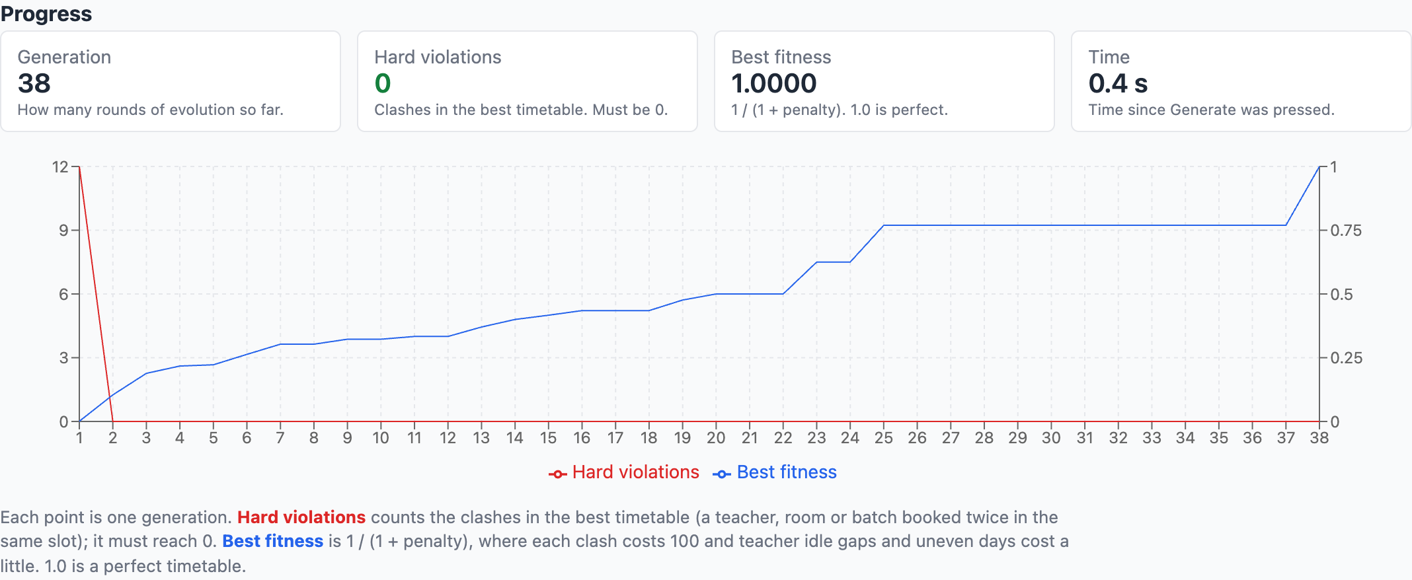
Figure 5.2: Convergence of Hard Violations and Best Fitness

5.3.3 Effect of the Repair Step
Without repair (the proposal's Steps 1–7 exactly) every run is still clash-free, but needs about seven times as many generations, and eight of ten stall short of 1.0: blind mutation changes two or three of the 48 genes per child, while repair changes only clashing genes.

Chapter 6: Conclusion and Future Recommendation

6.1 Conclusion
This project delivers a genetic algorithm, written from scratch in TypeScript, that builds a clash-free weekly timetable in well under a second: 2.2 generations and 26 ms mean on the sample data, with fitness 1.0 in every seeded run, and 384 ms mean on the earlier NFR1-sized dataset, against targets of 500 generations and 120 seconds. It follows the proposal's seven steps; its departures and the narrowed scope are listed in Section 1.4.3.
The main finding is that the textbook genetic algorithm, implemented faithfully, does solve the problem, but slowly, and it usually stalls short of fitness 1.0. A small repair step that moves only the clashing genes makes it about seven times faster and lets every run reach 1.0.

6.2 Limitations
- Unsaved data. Edits are lost on reload; departments, programmes and time slots can only be changed in src/data.ts.
- No persistence, login or export. The timetable disappears when the tab is closed.
- Simplified model. No laboratories, room types, departments or teacher availability.
- No completeness guarantee. The algorithm cannot prove that no timetable exists.
- Hand-tuned soft weights, chosen empirically rather than derived.
- Main-thread execution. A much larger dataset would make the page feel slower.

6.3 Future Recommendations
- Saved data and export: a database for edited data, editing of departments and time slots, and PDF/Excel export (FR1, FR5).
- Richer constraints: laboratories, room types, teacher availability.
- Minimal-perturbation rescheduling: when a teacher becomes unavailable, penalise distance from the existing timetable and seed the population with it, so few classes move.
- Web Worker execution for larger searches.

REFERENCES
[1] S. Even and Y. Itai, "On the complexity of timetable and multicommodity flow problems," SIAM Journal on Computing, vol. 5, no. 4, pp. 691–703, 1976.
[2] J. H. Holland, Adaptation in Natural and Artificial Systems. Ann Arbor, MI: University of Michigan Press, 1975.
[3] D. E. Goldberg, Genetic Algorithms in Search, Optimization, and Machine Learning. Reading, MA: Addison-Wesley, 1989.
[4] A. Colorni, M. Dorigo and V. Maniezzo, "Genetic algorithms and highly constrained problems: The timetable case," in Proc. 1st Int. Workshop on Parallel Problem Solving from Nature, Dortmund, Germany, pp. 55–59, 1990.
[5] D. Abramson, "Constructing school timetables using simulated annealing: Sequential and parallel algorithms," Management Science, vol. 37, no. 1, pp. 98–113, 1991.

APPENDIX

Appendix A — Screenshots
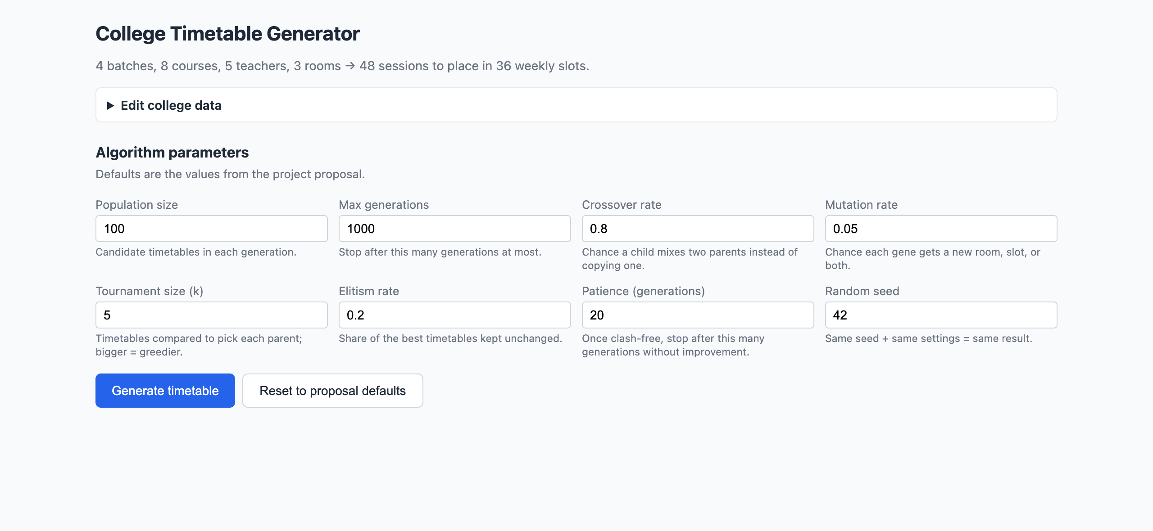 | The page before a run — dataset summary, parameter fields and Generate timetable button
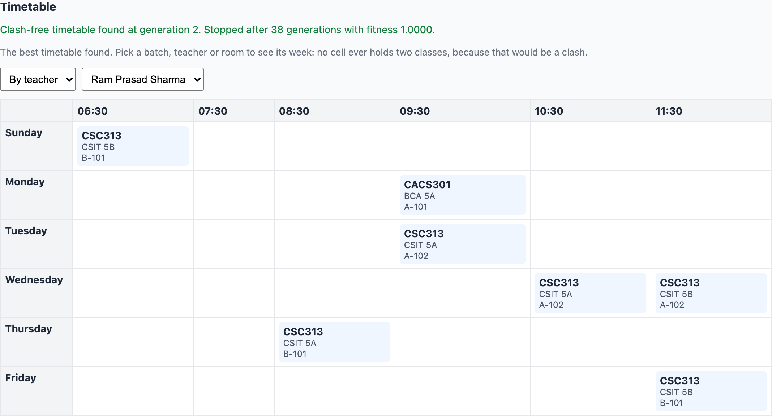 | Timetable, teacher view

Appendix B — Running the System
Run npm install, then npm run dev and press Generate timetable; npm test runs the ten tests. The default seed of 42 gives the same timetable every time.

